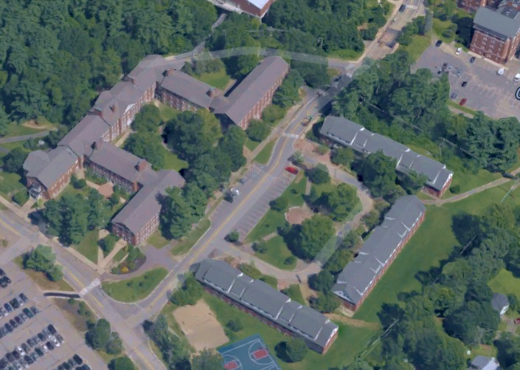

**ESCI 530 Field Geology Project 1:**

**Base Map of the UNH Quad**

**Abstract:**

The objective of this project is to show that when we are doing a geological field, it is important to have a base map. It helps visualize multiple as well as distinct physical features. Some examples are that in a base map, one might be able to see rivers, lakes, roads, and highways. For this project, we created a base map of the UNH Quad, which appears to be located between Morrill Hall, Main Street, Murkland Hall, and Demeritt Hall, and James Hall. We used various methods to be able to draw the base map with precision. Some of them include doing, pace and compass to determine the distance and plot its location. We also use a GPS to find the latitude and the longitude, as well as the elevation of the nodes/ locations.

The results vary a bit based on the type of method I used to plot the nodes, thus showing us the various errors that come when trying to make a base map. One of the important conclusions that can be drawn from this, is that a takes a lot of precision to draw a map and it requires trying and have precise calculations.

**Introduction:**

The project was to be able to construct a base map of the UNH quad by using equipment such as a GPS, protractor, and compass. We learned to build it from scratch, and this is important because it is these maps that geologists use to orient themselves when they are in the field. The field area where we did ours was not very complicated since there were few landforms that we used to locate our nodes and draw on the map.

Some of the landmarks, we were able to add, were like the bus stop, few lampposts, and some of the academic buildings. We did this to understand how to read and use maps as well as being able to locate certain observations such as outcrops and how to do it precisely. One of the questions we addressed was whether the path “closes” properly. In order to make sure that it did, we had to get our bearings right in our pace and compass map.

**Methods:**

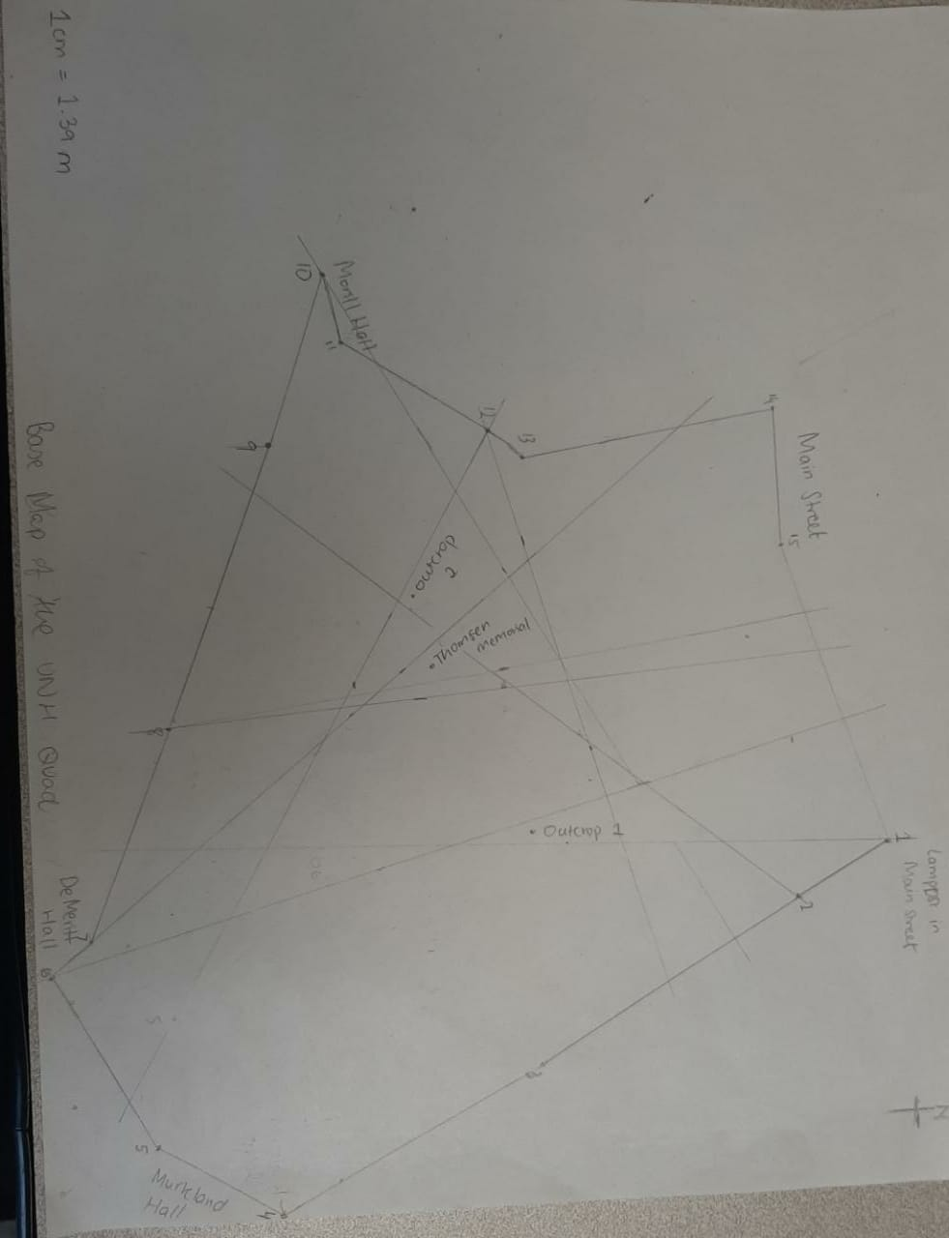In order to talk about the methods, we would have to divide the section into two. For the first part of the project, we used the pace and compass method. Through this, we used a compass bearing to find the azimuthal angle between two points. While the pacing is done walking the distance and counting the number of steps “paces” to cover the distance. Before we used the compass, we needed to make sure that it had the geographic magnetic declination. And according to the calculations, the declination in New Hampshire is roughly 15 degrees West. We used the Brunton Azimuth compass to get directional degree measurements. In order to get the bearing, I held the compass at waist height, and would then look down into the mirror and line up the target, needle.

On the other hand, for the pacing, I first measured and recorded my pace using one of the 30-meter measuring tapes. This was later used to help find a good scale for the map. I measured the number of paces it took to walk the longest distance and with it calculated my scale for the map. For certain outcrops, we used the triangulation method, where we took a couple of azimuthal angles to points of reference and use their intersection to determine the location of a feature. We record its’s bearings and then draw the triangulation lines lightly on the map. Finishing up with this, we used PowerPoint to create a digital replica of the base map of the UNH quad. It had the same features such as title, date, scale, north arrow, paths, outcrops, academic buildings, and Main St

*Pace and Compass (Fig 1)*

Another important method we used to make a base map is by using GPS, which stands for Global Positioning System. It has a 1cm to 30m accuracy and it is used numerous times for geologic mapping. It uses at least three satellites as reference points, and the position or the location is eventually calculated using trilateration and is done so by recording the precise amount of time it takes a digital signal to reach the receiver and converting that to distance.

**Distance = Velocity * Time**

In ties with the GPS, the World Geodetic System 1984 (WGS84) system was used for satellite navigation. It has a reference ellipsoid, a standard coordinate system, altitude data, and a geoid and is also believed to have an error of less than 2 centimeters. When I had to go onto the field to get the GPS coordinates, I first had to go to the satellite page of the GPS and wait until I had locked on to 4 or more satellites and this is to maximize accuracy and precision of the GPS location. I then noted down the longitude and the latitude as well as the elevation which was then imported on Google Earth.  One of the other things we took with the GPS was the outcrops and Thompson Memorial. With the pace and compass map, we used triangulation to locate where the outcrops were and when I had imported the coordinates to Google earth, it was a great way to compare the two methods.

**Results:**

Looking at Figure 1, it is the Pace and compass map, all the bearings and distances that were recorded in the field notebook were taken to make the map. From that, we converted it into a digital map in PowerPoint (Fig 2). While constructing the digital map, we had to adjust the length before we adjusted the rotation in order for it to be accurate. Symbols are important in mapping; I represented the outcrops with symbols as well as a few landmarks such as lampposts and academic buildings.

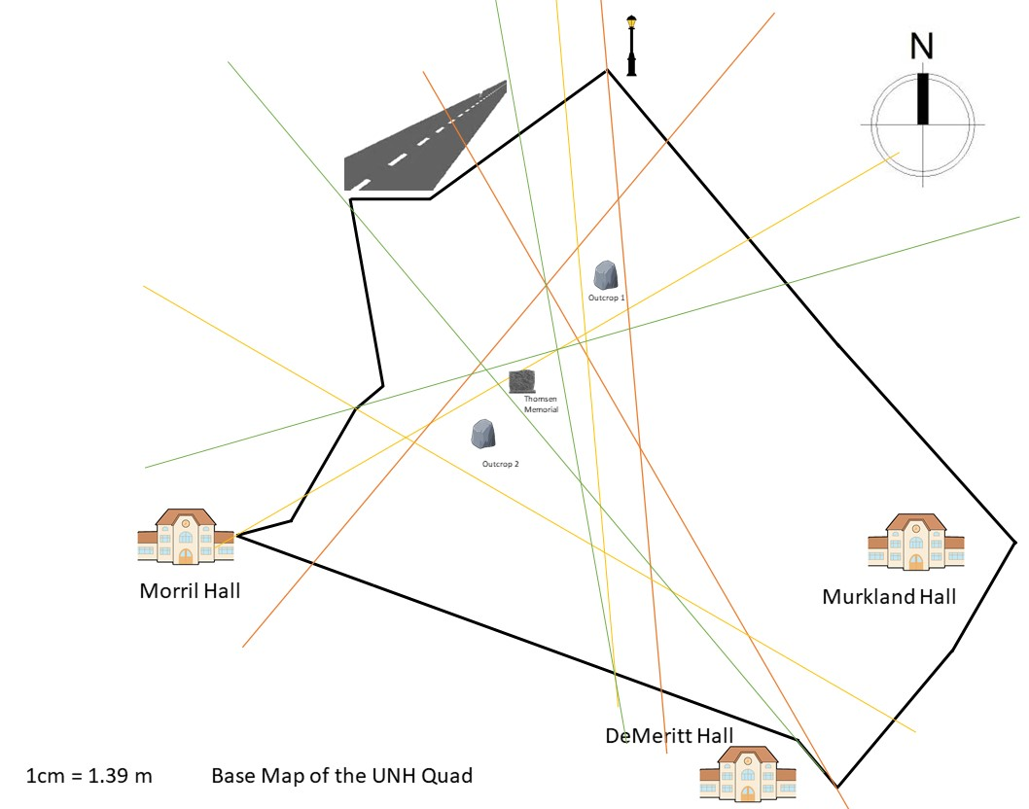

*Pace and compass map (Fig 2)*

Figure 3 and 4 are the GPS coordinates that was imported from the GPS onto the computer. The excel file that were created for it contained a lot of the information, it had the version, the time I took the GPS location, the latitude, longitude and the elevation. While Figure 3 was the nodes the path I had to draw, Figure 4 was the location of the outcrops and Thompson Memorial.

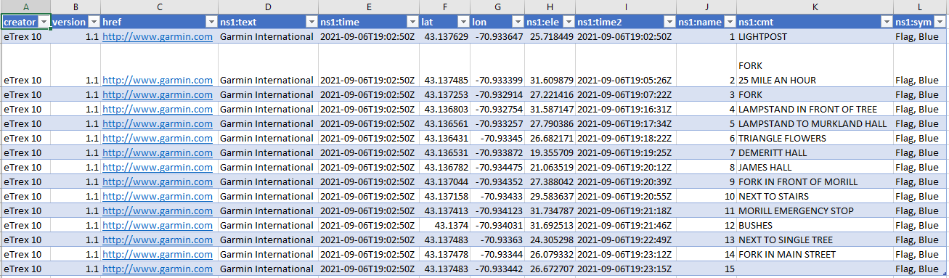

*GPS coordinates (Fig 3)*

*GPS coordinates (Fig 4)*

With this table, I imported the data into Google Earth, I had to slide the time slider in the upper left corner so it encompasses all of the relevant time that I took the coordinates. It was a bit hard to see all the waypoints but turning off the terrain made all the waypoints more visible. Figure 5 shows the pace and compass map too, we were able to use the Image Overlay button to add the digital map into google Earth. One of the final adjustments we did was to use the center cross hairs to move the map up/down and side-to-side so that one of the nodes will align GPS point for that node.

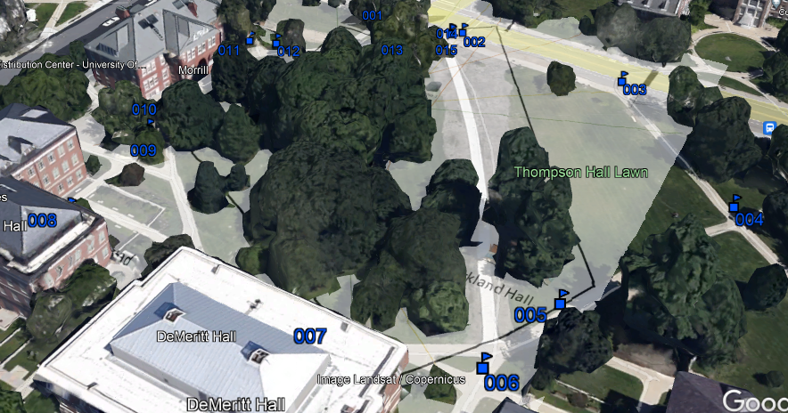

*Google Earth (Fig 5)*

With all the gathered and imported, I was able to use it to create an error analysis database. I was able to quantify the error associated with each method (pace and compass and GPS) of mapping and compare the two. In Google Earth I used the measuring tool in order to measure the distance between a point on the satellite image with the node in my map image. I then measured the distance from the same point on the satellite image to its corresponding GPS waypoint. The results were put onto a table to further calculate the accuracy and see the error.

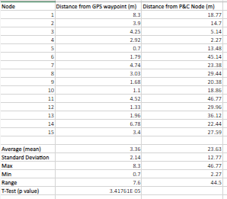

*Error Analysis (Fig 6)*

**Discussion:**

Looking at Figure 1, the pace and compass map had few errors. When I was measuring the bearing, my hand kept shaking trying to align the needle. The pointer in the compass was really helpful in getting the right direction and it made it more accurate. Another one of the factors that could have affected our results was the pacing. In my opinion the number of paces I do and the distance between each pace is constant totally depends on the terrain. Walking on straight paths, it made it easier to have a constant distance between the paces but when it came to going down a small hill, I would definitely say that my pacing could have not been very accurate and this definitely affected the length of a certain distance in the map. Another factor to take in would be students, they were walking around and especially after class ended, they would all be out, so there was time I had to pause my pacing or go around and this again did affect the number of paces. Bringing this all together, we can see in figure that the average distance from P&C node was 22.63. And the standard deviation is 12.77, which tells us that the data collected are more spread out, indicating a lot of errors.

            On the other hand, using the GPS was also not very accurate. We were asked to collect the GPS waypoints in our time, but when I collected mine it happened to be on a dark and gloomy day. I am not sure if the weather played an important role but it took time to connect with other satellites. In some locations I had six satellites while in others I would see only three. Another factor would be the location I took the GPS, even though I had descriptions about the nodes the GPS was taken a week later from the pace and compass method and there would definitely be slight error as to where I was standing and the position was the same in both the methods.

            Gathering all the data, I put them into excel and in order to calculate the error and accuracy. Google Earth provides satellite imagery that has certain reference points that I used to compare the two methods. Using the measurements, we took at google earth, I put them in excel to calculate the spread for each of the two groups of distances I measured. This was the mean, standard deviation, and range. For the pace and compass map, the average was 23.63 whereas for the GPS the average was 3.36, there is a huge difference between the two averages and it definitely factors in a lot more errors in the pace and compass map. After finding the average error for each method, I calculated the T-test to determine whether the two methods are statistically different from each other. The p value was less than 0.05 so we cannot reject the null hypothesis. This means that the data are not statistically different from each other.

**Conclusions:**

In conclusion, creating the base map of the UNH quad was done with two different methods and both had their own errors. Taking the GPS points was less time consuming and I felt they were more accurate because I have never made a field map before using bearings so the method was a bit confusing and there were times, I had to redo certain measurements. This put a lot of error in my map and it was quite evident because when I put the image overlay onto google maps, a lot of the nodes had a lot of distance between them and the reference positions in Google Earth. The distance from the P&C node had a 44.5 range whereas the distance from the GPS waypoints had a range of 7.6. This is clear evidence to show which was the better method to form a base map as well as the amount of errors I had on my pace and compass map.

**Reference cited**

Map and Compass - Troop 267 Salem NH. *Google Sites.* Date accessed September 17, 2021. <https://sites.google.com/site/troop0267salemnh/map-and-compass>

Brunton compass. February 02, 2021. *Wikipedia*. Date accessed September 17, 2021. <https://en.wikipedia.org/wiki/Brunton_compass>

World Geodetic System (WGS84). June 09, 2021. *GIS Geography*. Date accessed September 17, 2021. <https://gisgeography.com/wgs84-world-geodetic-system/>

Eight Reasons Why You Should Consider Base Map Creation Services. December 26, 2018. *The Engineering Design Technology*. Date accessed September 17, 2021. <https://www.theengineeringdesign.com/eight-reasons-why-you-should-consider-base-map-creation-services/>